CPE301 – SPRING 2019

Design Assignment 2B

Student Name: John Duriman

Student #: 5002373995

Student Email: duriman@unlv.nevada.edu

Primary Github address: https://github.com/johnduriman/pirahnaplant.git

Directory: pirahnaplant/Design Assignments/DA2B/

1. **COMPONENTS LIST AND CONNECTION BLOCK DIAGRAM w/ PINS**

ATMEGA328P

1. **INITIAL/MODIFIED/DEVELOPED CODE OF TASK 1/A**
2. **DEVELOPED MODIFIED CODE OF TASK 2/A from TASK 1/A**

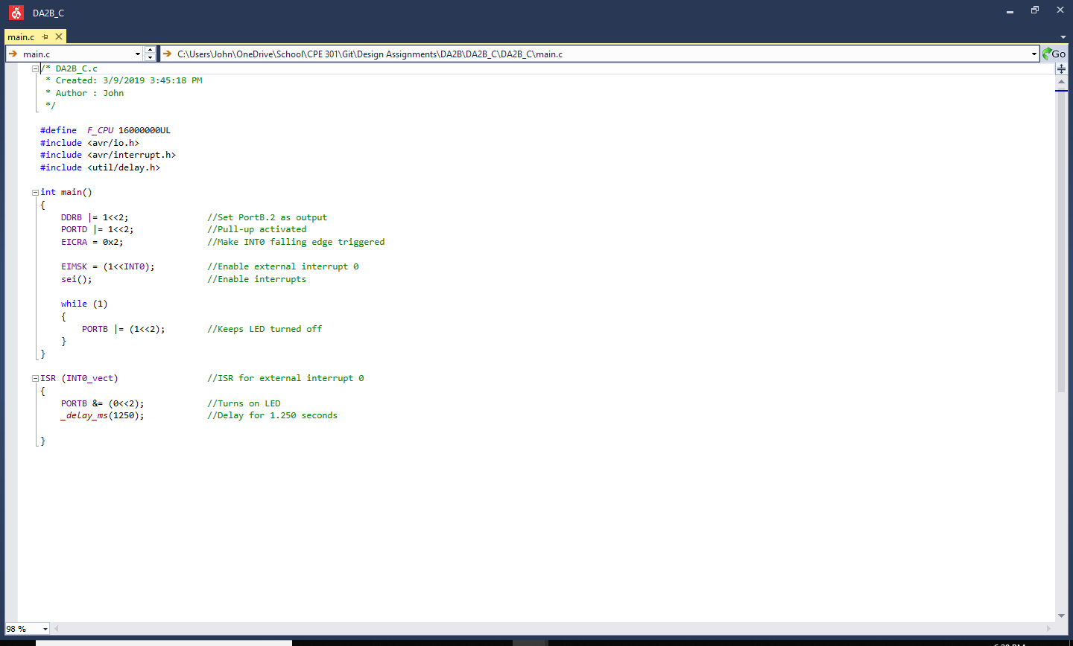

Task 1 in C

Port D.2 is used instead of the PORTC from the previous assignment. This activates the external interrupt 0 which then calls ISR.

Task 1 in Assembly

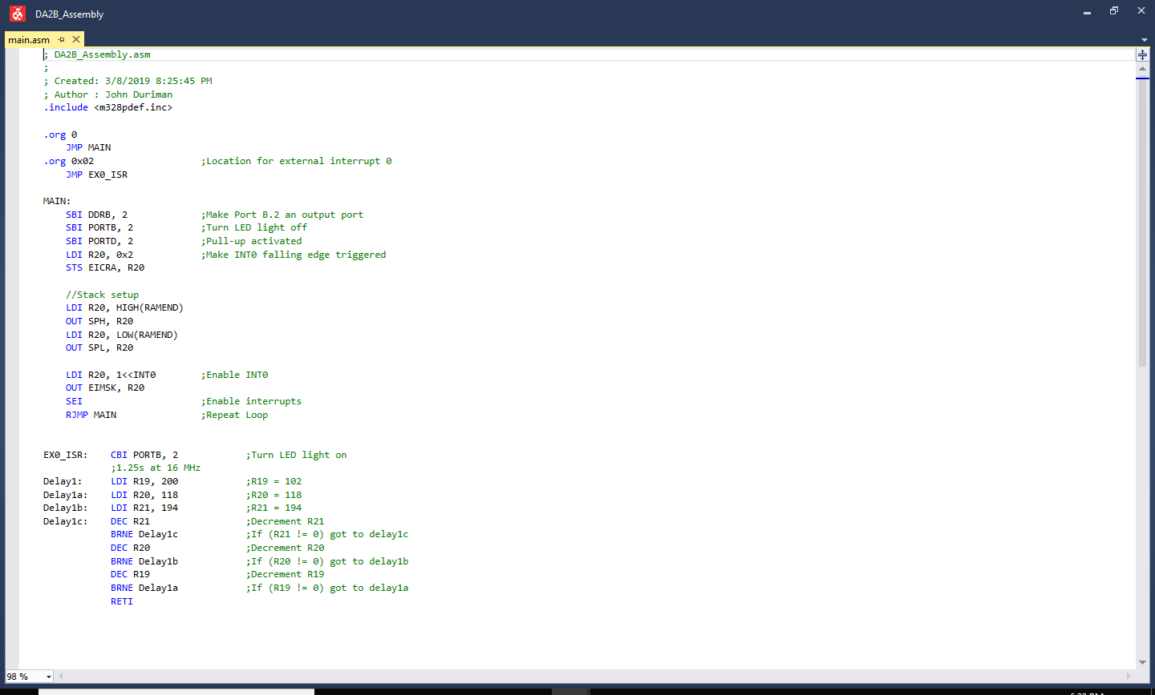

1. **SCHEMATICS**

Use fritzing.org

1. **SCREENSHOTS OF EACH TASK OUTPUT (ATMEL STUDIO OUTPUT)**
2. **SCREENSHOT OF EACH DEMO (BOARD SETUP)**

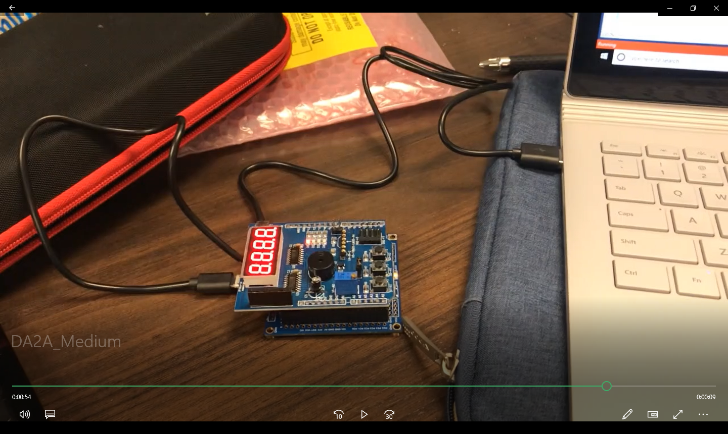

The task is setup the same way using the shield on top of the ATMEGA 328P. When PD2 is set to ground, an interrupt occurs, and the light turns on for 1.25 seconds and then turns off.

1. **VIDEO LINKS OF EACH DEMO**

<https://youtu.be/vxIhDrQb9i8>

1. **GITHUB LINK OF THIS DA**

https://github.com/johnduriman/pirahnaplant.git

**Student Academic Misconduct Policy**

<http://studentconduct.unlv.edu/misconduct/policy.html>

“This assignment submission is my own, original work”.

John Duriman